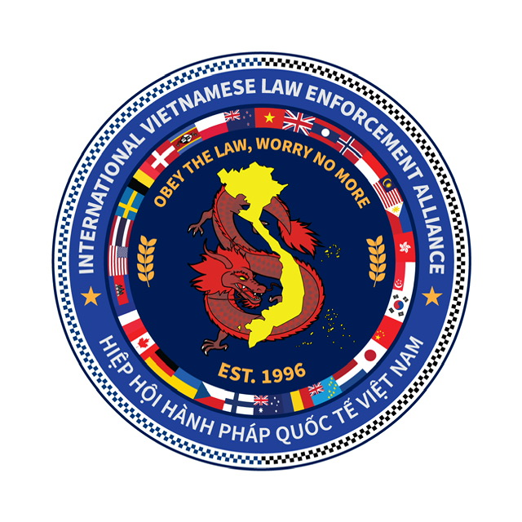

**IVA MEMBERSHIP REGISTRATION FORM**

**IVA Membership No._____ (Admin allocation)**

|  |  |
| --- | --- |
| **Surname** |  |
| **First Name** |  |
| **DOB** |  |
| **Address** |  |
| **Phone (M)** |  |
| **Phone (W)** |  |
| **Work email** |  |
| **Law Enforcement Agency** |  |
| **Serving or retired** |  |
| **Rank / Position / Title** |  |
| **Country / State/Region** |  |
| **Station / Squad/Unit** |  |
| **Years of Service** |  |
| **Emergency Contact** |  |
| **Relationship** |  |
| **Contact number** |  |

**PLEASE COMPLETE ONE FORM PER MEMBERSHIP**



**IVA MEMBERSHIP REGISTRATION FORM**

**One time membership fee of $20 per person is required at the time of completing the Membership Form. Payment must be done electronically to the following bank account:**

**Bank: Police Bank**

**BSB number: 815 000**

**Account number: 302181 (Please reference ‘Membership Fee and your name’)**

**Name: IVPA Social Club**

**Membership Fee: $20**

**Registration fee covers the following:**

**# Yearly Website fees**

**# Webhosting (storage space)**

**# Additional fee for future storage**

**# IVA Baseball Cap issued to members**

**Conditions of Membership:**

1. **International Vietnamese Law Enforcement Alliance (IVA) Membership is only open to current, retired, and unsworn members of Law Enforcement Agencies within Australia, around the world, and invitation as a guest subject to the approval of the IVA Committee.**
2. **Both those wishing to join the IVA Social Club as members and those who are current members, agree to immediately notify the IVA of any issues that may be contentious in nature. Such examples include but are not limited to being charged with any offence, criminal convictions, being subject to an order or restriction or being dismissed by their employer.**
3. **A committee established by the IVA will examine all matters of concern and make a recommendation to the IVA Committee if membership will be either granted in the first place or discontinued if a member already.**
4. **The above process will be adopted in order to protect the reputation and good standing of the IVA and its members. It is necessary that all member behaviour is of the highest character and integrity. The IVA committee reserves the right to reject or revoke current memberships.**
5. **By completing this Membership registration form you are expected to always conduct yourself in the highest standards of professional and respectful behaviour, and not bring yourselves, the IVA, or your home agency jurisdiction into disrepute.**

**Signed: Date:**

**NOTE: Please forward this form after completing to** [**info@ivpa.com.au**](mailto:info@ivpa.com.au) **or** [**luc@ivpa.com.au**](mailto:luc@ivpa.com.au)